
2026 LADA’s
Annual Conference


Seminar Cost Details:
LADA Member Fee ~ $85

Non-Member Fee ~ $100

Deadline to Register for the LADA Annual Conference is:
Monday, April 27, 2026
What: LADA Annual Conference
When: Thursday, May 21st from 8am-4pm
Where: Wood Crest Villa Viva Centre
2001 Harrisburg Pike Lancaster PA 17601

Full Conference Attendance will offer 6 CE’s
(Pending approval through NCCAP)

Conference Schedule: FYI Raffle Sales will also occur during breaks at 10a & 2p
- 7:45am – Registration, Continental Breakfast, and Raffle Sales
- 8:15am – Welcome by Ramona Little, ADC, CDP, LADA President
- 8:30am-10am – CEU Session 1: “Play Matters! Today and Beyond” with Nancy Richards, ADC/EDU
- 10:15am-11:45am – CEU Session 2: “Leading from the Inside: Emotional Intelligence & Self-Management” with Lisa Schaefer, CAE, CPM
- 11:45am-12:30pm – Lunch and Raffle Sales
- 12:30pm-2:00pm – CEU Session 3: “Leading Through Others: Emotional Intelligence in Relationships & Change” with Lisa Schaefer, CAE, CPM
- 2:15pm-3:45pm – CEU Session 4: “Who is the North Museum?” with Scott Downs and Molly Wolanski
- 3:45pm – Gift Basket Raffle Drawings and Closing Remarks
- 4:00pm – Distribution of Certificates

Raffle Tickets will be:
1 ticket for $1.00
6 tickets for $5.00
15 tickets for $10.00

If you have any questions regarding the seminar, please contact:
Ramona Little,
LADA President at rlittle@tandemlivingpa.org

Please fill out the bottom of this form for each registrant, and mail to the address below with your payment:
*** Please Note: Checks made payable to LADA ***
- - - - - - - - - - - - - - - - - - - - - - - - - - - - - - - - - - - - - - - - - - - - - - - - - - - - - - - - - - - - - - - - - - - - - - - - - - - - - - - - - - - - - - - - - - - - - - - - - - - - - - - - - - - - - - - - - - - - - - - - - -

Other Details:
We will be selling raffle tickets for baskets of goodies at the conference. Tickets will be 1 for $1, 6 for $5, or 15 for $10.
- Continental Breakfast – Assorted pastries, Fresh Fruit, Yogurt, Granola, and beverages will be available.
- Lunch – Soup & Salad, and Hot Buffet Lunch Options
- Assorted Desserts and Drinks
- Please List Any Special Dietary Concerns: ________________________________________________________
_____________________________________________________________________________________________________________

Registrant Name: _____________________________________________________________________________
Address: ____________________________________________________________________________________
Phone: __________________________________ Email: _____________________________________________

Deadline: Please detach & return this with your check by Mon., April 27, 2026
*There will be no refunds, but registration is transferable. *
**If registration transfer is needed, please notify us ASAP, so our records can reflect the change. Thanks! **
Mail to: Trillium Place Attention: Blanca Photis
1520 Harrisburg Pike, Lancaster, PA 17601

2026 LADA Conference

Meet Our Conference Speakers:

Nancy Richards, ADC/EDU
- Nancy is the Founder, Author & Possibility Maker of Activity Pathways, LLC, and is a PA native who lives in a small walkable town with plenty of wonder to explore. Nancy promotes the benefits of purpose, exploration and play, elements of human wellness. A graduate of Wesley College and Gwynedd Mercy University with an emphasis in Gerontology. Nancy speaks nationally, designs, and delivers products, released her second sensory activity engagement workbook, That Makes Sense! Sensory Ideas to Refresh Life in 2021. Is a Past President for the Pennsylvania Activity Professional Association, volunteers on the Education Council for the National Association of Activity Professionals (NAAP), nationally NCCAP certified and ardent supporter and mentor for people seeking NCCAP certification and recipient of the 2024 NAAP Award of Excellence. Nancy provides Creative Wellness programs to adults in an acute, co-occurring program in suburban Philadelphia.

Lisa Schaefer, CAE, CPM
- Lisa Schaefer is a Certified Association Executive, and Certified Public Manager with deep experience in leadership development and organizational effectiveness. A former nonprofit executive director and seasoned instructor, she brings nearly two decades of hands-on experience supporting leaders and building teams that can navigate complex challenges. Through her consulting firm, RealTalk Strategies, Lisa takes a practical, people-centered approach to helping leaders and organizations thrive.

Scott Downs and Molly Wolanski
- Scott Downs and Molly Wolanski are representing the North Museum of Nature and Science and serve in Development and Curatorial Departments respectively. The North Museum has been serving the Greater Lancaster area for over 70 years and continues to connect the wider public with STEM Education and opportunities. The Museum is home to 3 floors of exhibits and one of the largest Planetariums in the region! The current permanent exhibits include: our Nature Gallery, Live Animal Room, Fossil Exhibit, Ornithology (birds) and Geology Exhibits. The museum also has two rotating exhibit halls currently featuring Imagining Insects and Nature Reimagined.
- Scott Downs (he/him) is the Director of Development and Strategic Partnerships, where he oversees all fundraising endeavors at the museum. Scott has been with the museum for 6 years.
- Molly Wolanski (they/them) is the Exhibits and Collections Manager and has been serving in their role for 5 years. They also oversee the museum's volunteer program.

Nancy Richards
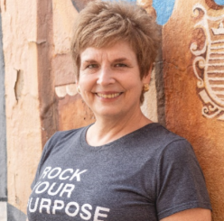

Lisa Schaefer
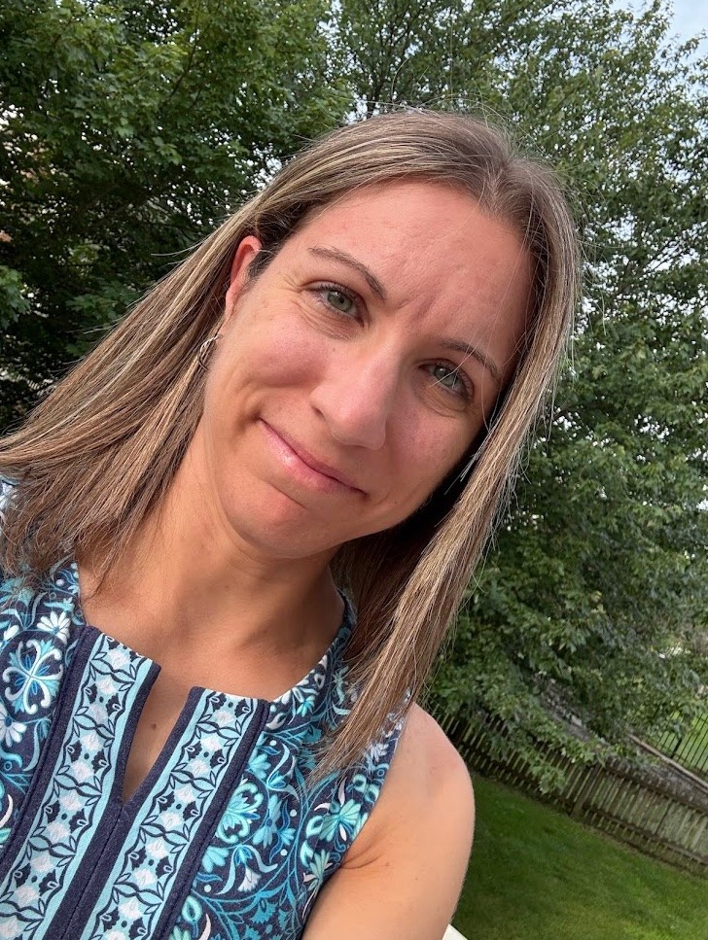

Scott Downs & Molly Wolanski
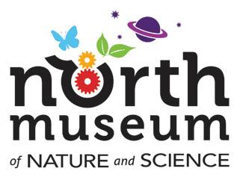

“Develop a passion for learning. If you do, you will never cease to grow.” – Anthony J. D’Angelo

If you have any questions regarding the seminar, please contact:
Ramona Little, ADC, CDP, LADA President at rlittle@tandemlivingpa.org

Session Descriptions for the Conference:
Thursday, May 21st, 2026
CEU Session 1 ~ 8:30am-10am (1.5 CEU’s)
- Nancy Richards, ADC/EDU
- “Play Matters! Today and Beyond”
  - Dr. Stuart Brown, a leading researcher and author on play said, “Play shapes the brain fostering empathy and is at the core of creativity and innovation.” Play stimulates the whole body and brain connection, mobilizing coordination, problem solving, reasoning, humor, social manners and affirms individuals and aids community cohesion. Play releases stress and is often a gateway to creativity. Explore the power of play across the lifespan, harness its magic to strengthen communication, consider how it impacts work culture and engagement in senior living.
CEU Session 2 ~ 10:15am-11:45am (1.5 CEU’s)
- Lisa Schaeffer, CAE, CPM
- “Leading from the Inside: Emotional Intelligence & Self-Management”
  - This session will focus on helping activity professionals manage their own emotions and reactions in a demanding, people-centered role, using practical emotional intelligence tools for daily leadership.

CEU Session 3 ~ 12:30pm-2:00pm (1.5 CEU’s)
- Lisa Schaeffer, CAE, CPM
- “Leading Through Others: Emotional Intelligence in Relationships & Change”
  - This session will aim to help activity professionals strengthen relationships with residents, families, and coworkers by using emotional intelligence to support communication, trust, and change.

CEU Session 4 ~ 2:15pm-3:45pm (1.5 CEU’s)
- Scott Downs & Mary Wolanski
- “Who is the North Museum?”
  - This session will aim to inform conference attendees on programmatic, educational, and other offerings and opportunities to engage your residents. Topics will include educational offerings at the museum, things that the museum can do at your facility, as well as what your residents can do off site.
B
The Lancaster Activities Directors Association…
… was established in 1980 to enhance the lives of elders by supporting, through networking and education, the people in Lancaster County and the surrounding area who work with them as activity professionals. Through monthly meetings, our website, and our annual conference, we provide opportunities for sharing new ideas and methods, working together to provide solutions to common challenges within our profession. We mentor those who are new to the profession and encourage all members to become highly qualified in the profession through certification and continuing education. We promote the work of activity professionals both within communities serving seniors and to the public. We encourage and support state and national participation within our organization.
To join, visit http://www.joinlada.org/join.html

